How do add new target to monitoring

1. Connect to Zabbix frontend

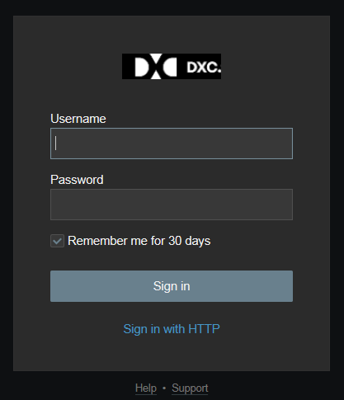

1. Navigate to Configuration -> Hosts and click on Create Host button

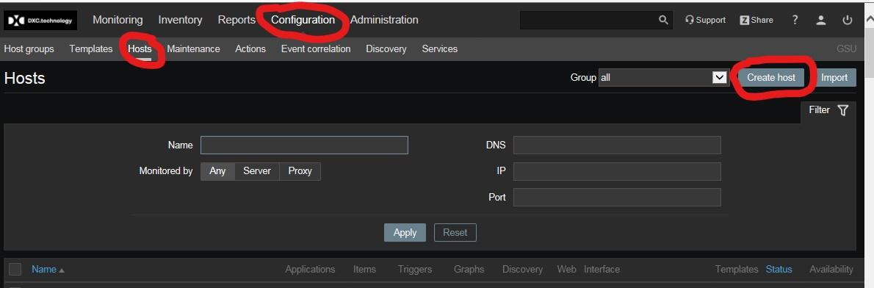

1. Host tab:

* Host name in format – DB2LUV hostname.domainname DATABASENAME
* Group for the target – IBM DB2 LUW Databases (it will be added automatically as part of template)
* Agent interface -> IP address of appropriate management host where monitoring scripts will be executed

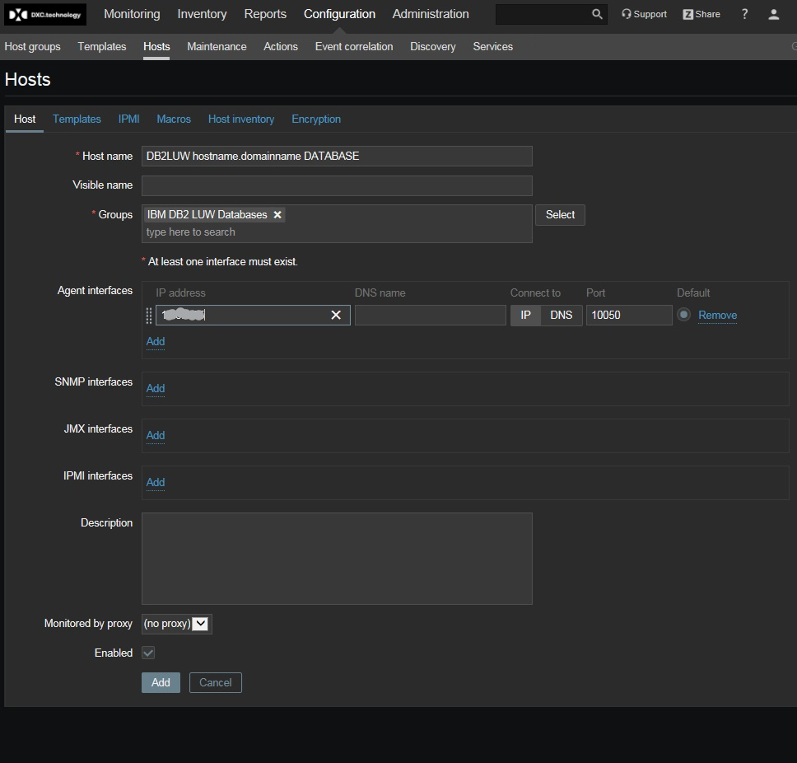

1. Templates tab

* For standalone server add template for database monitoring and template for OS monitoring (Linux or Windows). To add templates after selection ‘Add’ link has to be clicked on.

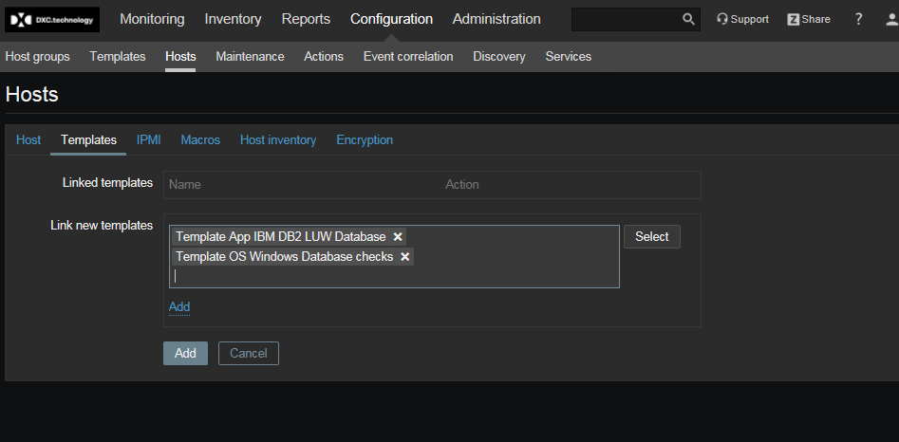

* For cluster configuration monitoring of OS and database should be separated as different end points

1. Macro tab, after adding templates go to ‘Inherited and Host Macros’ part

At least the following fields has to be updated

* {$HOSTNAME} – target’s connection details, hostname or IP, depending on what is accessible
* {$SERVICE} – database name
* {$USERNAME} – username for connection to the database, it should have appropriate privileges to get data
* {$PASSWORD} – encrypted password for username, it has to be encrypted, see below
* {$PORT} – it can be required if listening port is not default (50000 for DB2 LUW)

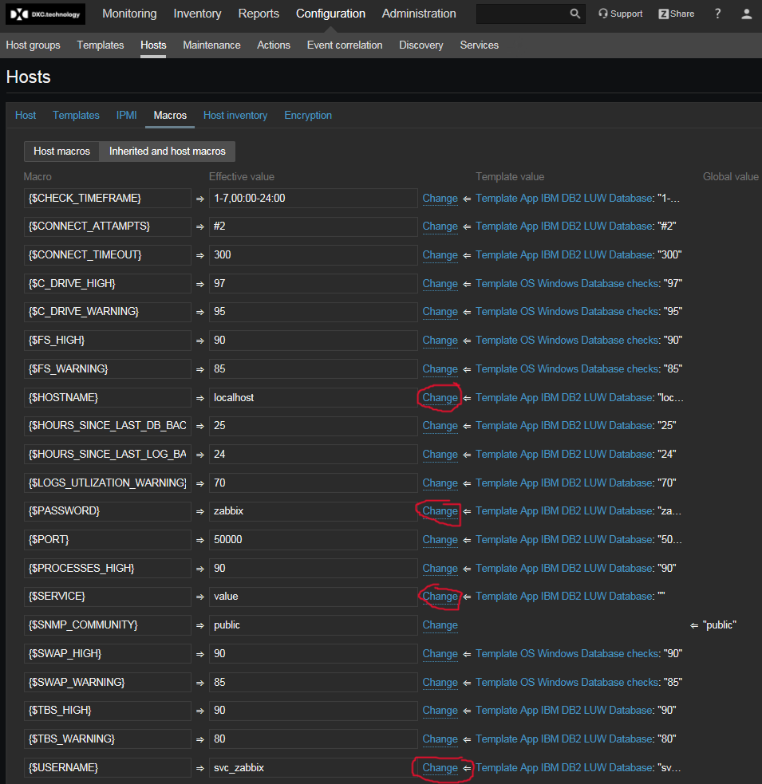

1. Password provided in {$PASSWORD} is encrypted by key on appropriate management host

To create encrypted string – connect to management server and execute D:\DBA\zbxpwsh\bin\pwgen.ps1 (command line or PowerShell ISE)

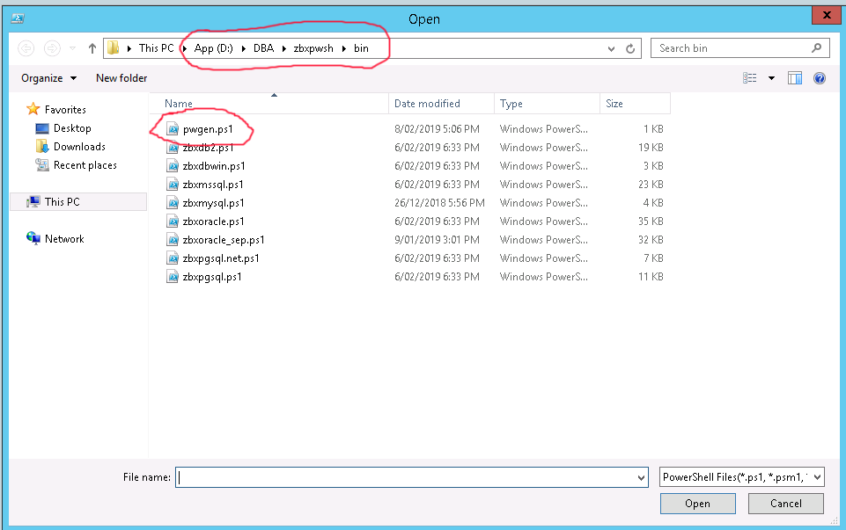

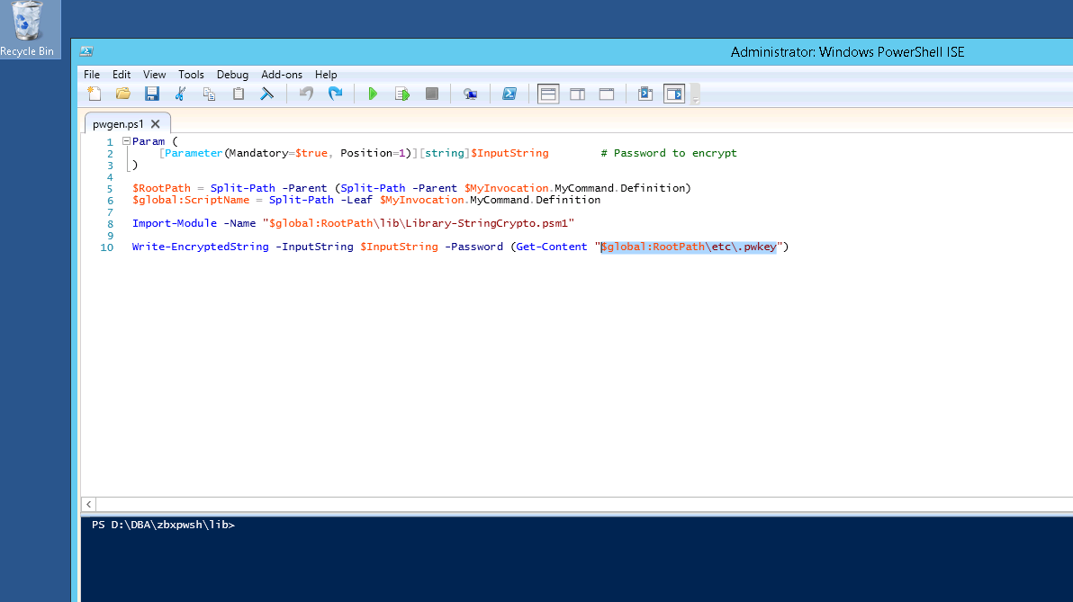

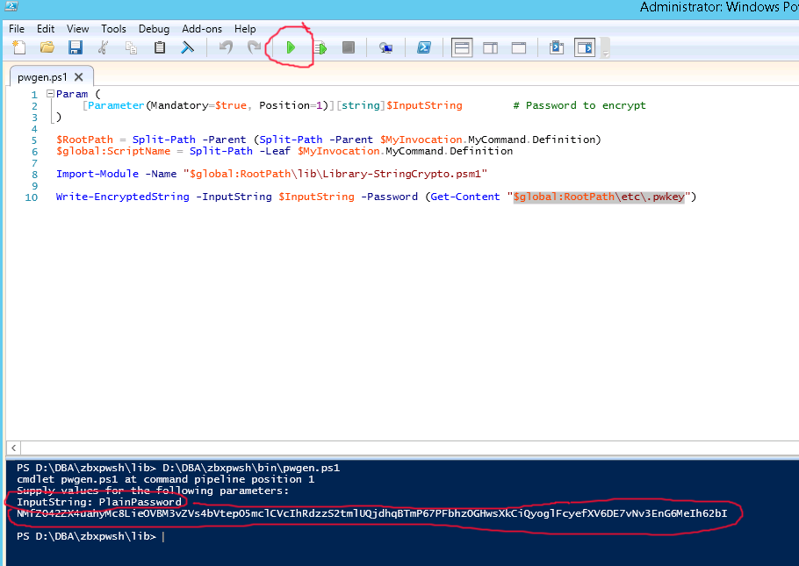

1. Click Add button and new endpoind will be added

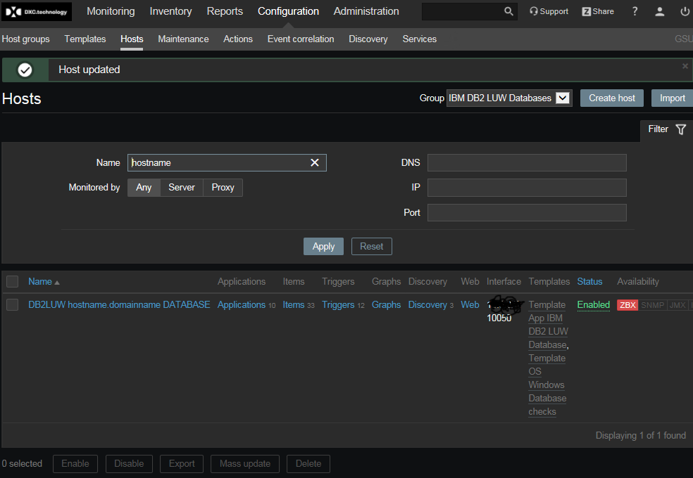

1. It will take some time before agent on Management host contacted. Also, discovery normally runs every hour, so as soon it was run – appropriate targets will be created